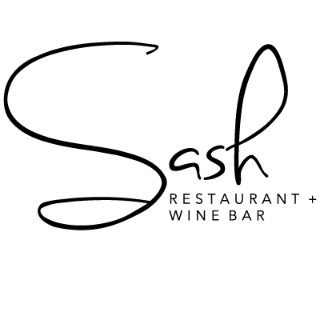
Appetizer

Waterborne greens / Black plums
shaved Manchego, orange, champagne vinaigrette, aged balsamic
$16

Sash salad
Roasted cauliflower, hydroponic arugula, crispy lentils, curry yogurt, citrus
$16

Poached cocktail shrimps, classic horseradish sauce, lemon
$22

Main Course

Dover sole, steamed Peruvian potatoes, French green beans, meuniere sauce
$80

Grilled seabream (whole), basmati rice, French green beans, lemon
$60

Chilean sea bass, madras curry, coconut milk, okra, vegetable pakoras, coriander
$45

Pan seared chicken supreme, pomme puree, spinach, asparagus, natural jus
$36

Roasted Australian lamb rack, leek risotto, asparagus, natural jus
$40

Braised beef short ribs, pomme puree, roasted brussels, root vegetables
$36

BBQ pork ribs, house BBQ sauce, cole slaw
$32

Sides

Fries $6
Onion rings $6
Parmesan risotto $14
Foraged wild mushrooms, thyme $12
Steamed broccoli $12
Basmati rice $6

Dessert

Classic cheesecake, berry compote
$12

Fresh fruits, berries
$12

